**WORK INSTRUCTIONS FOR_ CASTHOUSE JOBS TO BE CARRIED OUT DURING SHUTDOWN OF FURNACE**

Responsibility: Shift Superintendent

Criteria: Safe working

**Identified Hazards:**

1. BF Gas leakage
2. Contact with hot shell
3. Fall of a person from height
4. Nonuse of PPE
5. Improper house keeping
6. Inadequate local lighting
7. Doing the job in hurry
8. Fire and explosion
9. Contact with hot water
10. Fall of material from Height
11. Outburst of fused metal/slag during tuyere changing

Significant Aspect:

1. Emission of BFG

2. Usage of water

3. Generation of dust

1. Tuyere & Tuyere cooler fitting & removal

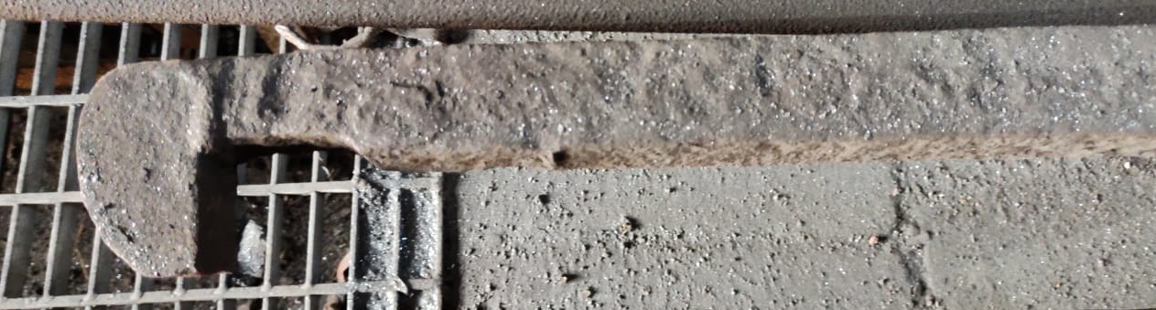

Responsibility: Furnace In charge

• Unauthorized operation or repair of any equipment is a punishable offence

• Use all personnel protective equipment (, shoes, goggle & helmet) before starting the job.

• Start removing the blowpipe after furnace shut down and all the blowers are put off.

• Before removing the tuyere or tuyere cooler, the people who are working on bleeder valve should stop their job, as both the jobs should not be carried out simultaneously.

• Open and clean the tuyere & pull out the tuyere with the help of tuyere puller.

• Ensure 75 mm thick brick is placed on both side of the inlet pipe of tuyere cooler to avoid damage to the pipe.

• Take the measurement of the tuyere old seating (distance from outside edge of the cooler) before taking the tuyere down on ground remove the water hoses (inlet & outlet) after stopping the inlet water.

• Take the tuyere down on the ground by sliding it on the MS pipe (MS pipe-1 and half to 2 inch or a poking rod with 3-4 m length) with 2 persons on each side holding the tuyere & one person to hold the rod, to avoid slipping.

• Plug the tuyere with hydrous clay to prevent coke falling down & air entering in.

• Clean the area of tuyere seating so that violent hammering of tuyere can be avoided

• Lift the new tuyere manually with the help of MS pipe by minimum four people & place over the opening after fitting inlet & outlet metallic pipes.

• Connect the water hoses to inlet, outlet & start water.

• Place the wooden plank on the outer ring of the tuyere & with the help of tuyere puller hammer the wooden plank to fit the tuyere in its position, ensure that the inlet and outlet pipe doesn’t foul with the tuyere cooler inlet and outlet pipes

• Care should be taken that the blowpipe seat should not get damaged & inlet & outlet pipe should not leak.

• Tuyere should go up to the previous distance as measured before and the outlet pipe should be in top position.

• After proper fitting of tuyere, inlet valve to be fully open & give clearance to mech. for fitting the blow pipe after plugging tuyere.

• Bleeder jobs can be carried out after plugging the tuyere.

• Old tuyere should be returned to stores as scrap at the earliest latest by next working day.

1. Bottom trough cleaning

Responsibility: Furnace In charge/Foreman/Sr. Tap hole operator

• Check the CO presence with the help of detector

• Ensure that all the personnel are wearing PPE

• Do not allow any body to enter inside the trough as the water is hot

• Ensure all persons working in cast house are aware of the persons below the cast house.

• Keep watch on red spots below the main runner it could be a weak point for runner puncture.

1. Cleaning near the ladle placement area

Responsibility: Furnace In charge/PCM In charge

• Ensure that the all the people are wearing proper PPE

• Ensure that there is no work is going on near the metal lauder spout

• Ensure there is no movement of moving machinery or ladle

• Ensure all the personnel working above the area are aware of the cleaning activity going on below.

1. Cleaning and replacing the screens in slag granulation pit

Responsibility: Furnace In charge

• Ensure that all the water is drained out of the pit

• Ensure that slag pit is completely cleaned

• Ensure that electrical shutdown of both slag granulation pumps is taken, and all valves kept closed.

• Barricade the entrance of the pit

• Give clearance for replacing the screens

1. Shell scraping

Responsibility: Furnace In charge

• Ensure that there is no BFG with the help of CO detector

• Wear all the PPE including safety belt

• Ensure proper bamboo scaffolding around the furnace.

• Ensure furnace shell is not hot.

• Ensure shell cooling valves are kept closed and No shell cooling trials are conducted during the scraping activity.

• Ensure persons involved are trained for the activity.

1. Tuyere Lancing when filled with slag

Responsibility: Furnace In charge

• Ensure that the people are wearing all safety appliances, viz, safety helmet with face shield, shoes, safety over coat etc.

• Unauthorized operation or repair of any equipment is a punishable offence.

• Pack the tuyere opening with coke pieces

• Place sand on and around inlet pipe of tuyere cooler.

• Take care that oxygen blown burns the coke which in turn melts the slag.

• Ensure lancing pipe is not burned during blowing of oxygen.to avoid accidental puncturing of the tuyere with lancing

• Ensure 3 kg/cm2 steam pressure is maintained in uptakes and dust catcher

7. Cleaning of blowpipe filled with slag

• Ensure that the people are wearing all safety appliances, viz, safety helmet, shoes, hand gloves etc

• Open the blowpipe flange

• Use crowbar, lancing hook to clean the blowpipe of slag

8. Inspection / Plugging & opening of Tuyere

Responsibility: Furnace In charge /foreman/Sr.Taphole operator

• Use all the safety PPE like helmet with screen hand gloves etc. during plugging, inspection and opening of tuyeres.

• Use dry poking rod for tuyere inspection.

• Insert the rod in the tuyere & check for water leakage, one rod should be used for maximum two tuyeres. Opening the plugged tuyere should be done using the modified rod.

• Plug the tuyere with hydrous / pottery clay with the help of talli, after inspection of tuyeres.

• Ensure only two tuyeres peephole flanges are kept open where people movement is less preferably tuyere no.1 and 8 and others to be loosely closed.

• Keep the tools at proper place after the job is completed.

• Handle of the hammer to be checked prior to usage for any damage not to be used in case of damage. Wooden handle hammers have been replaced by hardened rubber handles.

• Sufficient safe distance from the point of hammering to be maintained.

• Ensure that the asbestos blanket Infront of tuyere is lowered before taking shutdown

While grouting hearth area no one should work on tuyere area/removal/sitting as grouting material can come out with pressure/explosion and cause burn injury.

Any water line trial should be taken in presence of production engineers only.

9. Housekeeping in Blast furnace area

Responsibility: Furnace In charge

• Ensure that the all the people are wearing proper PPE

• Ensure that there is no work is going on main runner, drill machine or mudgun

• Ensure there is no movement of moving machinery or crane

• Ensure all the personnel working above the area are aware of the cleaning activity going on below.

|  |  |  |
| --- | --- | --- |
| Prepared By:  Head – Production PID I | Reviewed & Issued By:  Management Representative | Approved By:  Head – Pig Iron Division |
| Signature: | Signature: | Signature: |
| Date: **10.07.2023** | Date: **10.07.2023** | Date: **10.07.2023** |

|  |  |  |  |
| --- | --- | --- | --- |
| **Amendment Record** | | | |
| **Revision date** | **Manual Section ref. and para** | **Brief details of revision** | **New Revision No.** |
| 15.07.2022 | Work instructions for cast house jobs to be carried out during shutdown of furnace | Hazards identified | 15 |